TASK # 01

Create a function which display your Name, Reg no, Class, Section.

Display all the things within the body of function, call the function in main.

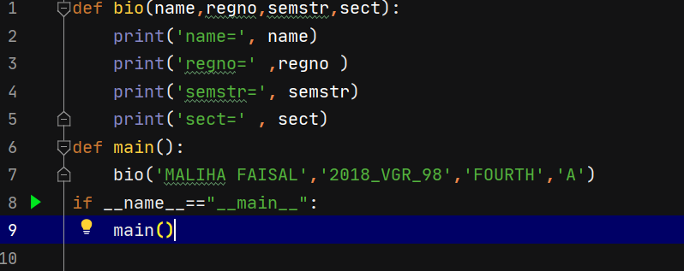

Output:

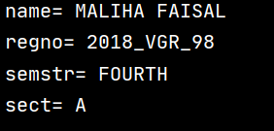

TASK # 02

Create a function SUM in C++ which calculates the sum of 5 numbers entered by user.

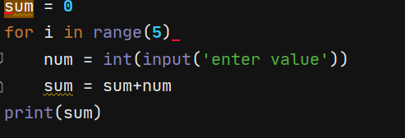

Output:

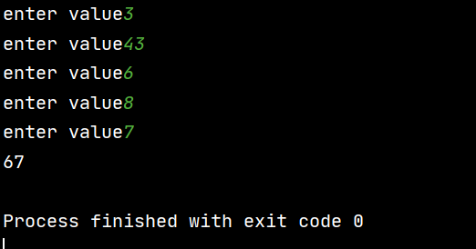

**By function** :

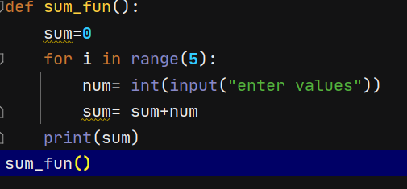

TASK # 03

Create a function IS_Prime which take a number as argument, return TRUE if number is prime.

Take number from user at run time.

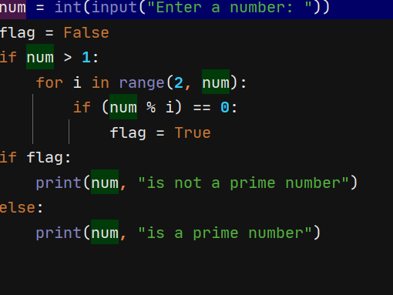

Output:

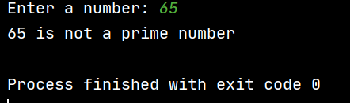

TASK # 04

Create a calculator using functions

make separate functions for each of the following operators +, -, *, /, %

Give user choices for operator, call the required function accordingly

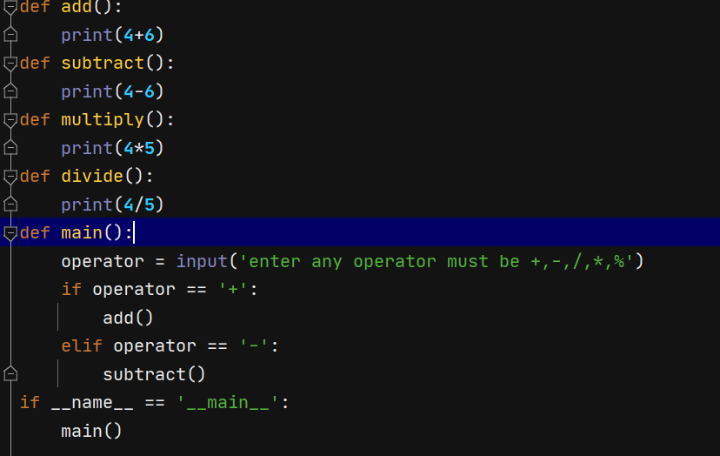

Output



TASK # 05

Create a function table of which take a number as argument and print the table of that number into reverse order from 12 to 1.

